GlamMatch
Personalized Styling & Salon Connector App
Software Engineering Lab
Deliverable #4 - Iteration 3 / Sprint 3 Report

Name | Roll Number | Role
Ayza Ahmed | 24L-2577 | Project Lead + Requirement Engineer
Eman Adil | 24L-2589 | Backend + Database Developer
Anoushay Fatima | 24L-2585 | Frontend Developer + UI/UX + QA Tester

Course: Fundamentals of Software Engineering
Project Type: Website / Web Application
Date of Submission: 3rd May 2026

1. Project Introduction

1.1 Project Title
GlamMatch - Personalized Styling & Salon Connector App

1.2 Introduction
GlamMatch is a web-based styling and salon connector platform that helps users receive personalized fashion and beauty guidance. The system uses undertone quiz results, body type questionnaire results, photo-based skin tone and face shape analysis, wardrobe inputs, and product recommendation rules to generate styling suggestions. It also helps users discover salons, view service catalogs, request appointments, chat with salons, and post reviews after appointment completion.
The project was developed incrementally across three sprints. Sprint 1 delivered the core styling system. Sprint 2 added advanced styling features such as photo analysis, wardrobe suggestions, product recommendations, and face shape-based hairstyle/hijab/earring suggestions. Sprint 3 completes the platform by implementing the Salon Connector Platform: salon discovery, salon profile, appointment booking, chat, and reviews.

1.3 Technology Stack
Layer | Technology Used | Purpose
Frontend | HTML5, CSS3, Vanilla JavaScript | Single-page GUI screens, navigation, validation, API calls, face-api.js integration
Backend | Python 3 + Flask | REST API, authentication, business logic, quiz processing, bookings, chat, reviews
Database | SQLite | Persistent storage for users, quiz results, wardrobe, products, salons, bookings, messages, reviews
Authentication | JWT token-based session handling | Protects user-specific routes and profile data
AI / Client Analysis | face-api.js models | Face detection / landmark support for photo-based face shape analysis

2. Sprint Backlog for Sprint 3

2.1 Module Name
Salon Connector Platform - Discovery, Booking, Chat and Reviews

2.2 Sprint Goal
The goal of Sprint 3 is to complete the salon connector side of GlamMatch so a registered user can search for salons, view salon details and services, request an appointment, track booking status, chat with the salon, and submit a post-appointment review.

2.3 Selected User Stories for Sprint 3
US # | Story ID | User Story Title | Priority | Story Points
11 | US-11 | Find nearby salons with filters | Must Have | 5
12 | US-12 | View salon profile and services catalog | Must Have | 5
13 | US-13 | Request appointment booking and track status | Must Have | 8
14 | US-14 | Chat between client and salon | Should Have | 5
15 | US-15 | Rate and review salon after appointment | Should Have | 5

3. Sprint 3 User Stories with Sub-User Stories

US-11: Find nearby salons with filters
Field | Description
Story ID | US-11
As a... | user looking for a suitable beauty service
I want to... | find nearby salons using search and filters for service, price range, and category
So that... | I can discover salons that match my preferences before booking
Acceptance Criteria | 1. Salon list is displayed with name, address, rating, price range, category, and distance/area information. 2. Search and filters update results without page reload. 3. Each salon card opens the detailed salon profile. 4. If no salon matches filters, a clear empty-state message is shown.
Priority | Must Have
Story Points | 5

Sub-Story | Title | Description
US-11a | Salon Search | As a user, I want to search salons by name or address so I can quickly locate a relevant salon.
US-11b | Service Filter | As a user, I want to filter salons by service type such as makeup, hair, bridal, skincare, or nails so I can view only relevant salons.
US-11c | Price and Category Filter | As a user, I want filters for price range and women/men/unisex category so the results match my budget and preference.
US-11d | Salon Cards | As a user, I want each salon card to show rating, address, price range, and service tags so I can compare options quickly.

US-12: View salon profile and services catalog
Field | Description
Story ID | US-12
As a... | user who has selected a salon
I want to... | view full salon details, services, prices, timings, and reviews
So that... | I can make an informed decision before sending a booking request
Acceptance Criteria | 1. Profile page shows salon information and services catalog. 2. Services include price range and estimated duration. 3. Reviews and average rating are visible. 4. Book Appointment action opens the booking form with selected salon context.
Priority | Must Have
Story Points | 5

Sub-Story | Title | Description
US-12a | Salon Information | As a user, I want to view salon name, address, phone, working hours, and description so I can judge reliability.
US-12b | Service Catalog | As a user, I want to see service names, types, price ranges, and duration so I can select the correct service.
US-12c | Reviews Section | As a user, I want to view ratings and previous reviews so I can assess service quality.
US-12d | Booking CTA | As a user, I want a clear Book Appointment button on the profile so I can start booking without searching again.

US-13: Request appointment booking and track status
Field | Description
Story ID | US-13
As a... | registered user ready to book a service
I want to... | choose a service, date, time, and note, then submit a booking request
So that... | the salon can confirm, reject, or propose an alternate time and I can track the status
Acceptance Criteria | 1. Booking requires salon, service, date/time, and authenticated user. 2. New booking is saved with Pending status. 3. Status can be updated to Confirmed, Rejected, Alternate, Completed, or Cancelled. 4. User can view all bookings with service and salon details.
Priority | Must Have
Story Points | 8

Sub-Story | Title | Description
US-13a | Booking Form | As a user, I want to select service, date, time, and optional note so my appointment request is complete.
US-13b | Booking Status | As a user, I want to see Pending, Confirmed, Rejected, Alternate, Completed, or Cancelled status so the process is transparent.
US-13c | Alternate Slot Response | As a user, I want to accept or decline an alternate slot so I remain in control of appointment timing.
US-13d | Booking List | As a user, I want all bookings in one My Bookings screen so I can manage upcoming and previous appointments.

US-14: Chat between client and salon
Field | Description
Story ID | US-14
As a... | user with an active booking or selected salon
I want to... | send and receive messages with the salon
So that... | I can clarify appointment timing and service requirements directly
Acceptance Criteria | 1. Chat is linked with a booking. 2. Messages store sender type, message text, and timestamp. 3. User and salon messages are visually separated. 4. Chat history reloads when the chat is reopened.
Priority | Should Have
Story Points | 5

Sub-Story | Title | Description
US-14a | Open Chat | As a user, I want to open chat from booking or salon profile so I can discuss the appointment.
US-14b | Send Message | As a user, I want to type and send a message so my query reaches the salon.
US-14c | Conversation Thread | As a user, I want messages to appear in timestamped bubbles so the conversation is readable.
US-14d | Saved History | As a user, I want chat history saved so I can revisit previous confirmations.

US-15: Rate and review salon after appointment
Field | Description
Story ID | US-15
As a... | user whose appointment is completed
I want to... | submit a star rating and written review
So that... | other users can benefit from real service feedback
Acceptance Criteria | 1. Review form is available after appointment completion. 2. Rating must be between 1 and 5. 3. One user cannot review the same booking twice. 4. Review appears on the salon profile and contributes to average rating.
Priority | Should Have
Story Points | 5

Sub-Story | Title | Description
US-15a | Rating Form | As a user, I want to select 1 to 5 stars and write a review so I can share my experience.
US-15b | One Review Per Appointment | As a system, I want to restrict duplicate reviews so ratings remain fair.
US-15c | Publish Review | As a user, I want my review to appear on the salon profile so it helps future users.
US-15d | Rating Update | As a salon visitor, I want average rating and review count to update after a review so the profile remains accurate.

4. User Stories - All Sprints
The following table consolidates all user stories from Sprint 1, Sprint 2 and Sprint 3. Sprint 3 completes the end-to-end GlamMatch workflow by adding salon discovery, appointment management, communication, and reviews.
US ID | Sprint | Title | Status
US-01 | Sprint 1 | Create user account and login | Complete
US-02 | Sprint 1 | Take undertone quiz | Complete
US-03 | Sprint 1 | Get personalized color palette | Complete
US-04 | Sprint 1 | Receive basic styling suggestions based on undertone | Complete
US-05 | Sprint 1 | Complete body type questionnaire and receive styling insights | Complete
US-06 | Sprint 2 | Upload selfie and get skin tone / undertone estimate | Complete
US-07 | Sprint 2 | Detect face shape from uploaded photo | Complete
US-08 | Sprint 2 | Receive makeup and clothing product recommendations | Complete
US-09 | Sprint 2 | Upload wardrobe items and get outfit suggestions | Complete
US-10 | Sprint 2 | Get face shape-based style suggestions: hairstyle, hijab and earrings | Complete
US-11 | Sprint 3 | Find nearby salons with filters | Complete
US-12 | Sprint 3 | View salon profile and services catalog | Complete
US-13 | Sprint 3 | Request appointment booking and track status | Complete
US-14 | Sprint 3 | Chat between client and salon | Complete
US-15 | Sprint 3 | Rate and review salon after appointment | Complete

5. Design

5.1 Sprint 1 Design Summary
- Login and Register screens: card-based forms with email/password validation and inline error messages.
- Home screen: dashboard with navigation to style analysis, wardrobe, products and salon connector.
- Undertone quiz: step-by-step question flow with progress control and result screen.
- Color palette screen: recommended and avoid color swatches categorized into clothing and makeup shades.
- Body type questionnaire: self-reported proportion questions with body type result and styling tips.

5.2 Sprint 2 Design Items
Sprint 2 design focused on advanced styling functions. The report references the following design artifacts from the earlier sprint: activity diagrams, use case diagram, sequence diagrams, and class diagram.
Design Artifact | Purpose
Activity diagrams | Show the flow for photo upload, wardrobe upload/outfit generation, and face shape-based style suggestions.
Use case diagram | Shows actors and complete styling use cases for registered user, guest/visitor, face-api.js service, and database.
Sequence diagrams | Show object interaction among User, Browser, Flask API, face-api.js, and SQLite database.
Class diagram | Shows domain classes such as User, PhotoAnalysis, WardrobeItem, ProductRecommendation, Wishlist, StyleSuggestion, and related classes.

5.2.1 Activity Diagrams
Activity diagrams are drawn for the three main processes of Sprint 2.

Photo Upload & Skin Tone / Undertone Analysis (US-06)
Shows the flow from the user selecting a photo, system validating and processing the image, the analysis service extracting skin tone and undertone, displaying results, handling the privacy prompt, and storing the result to the profile.
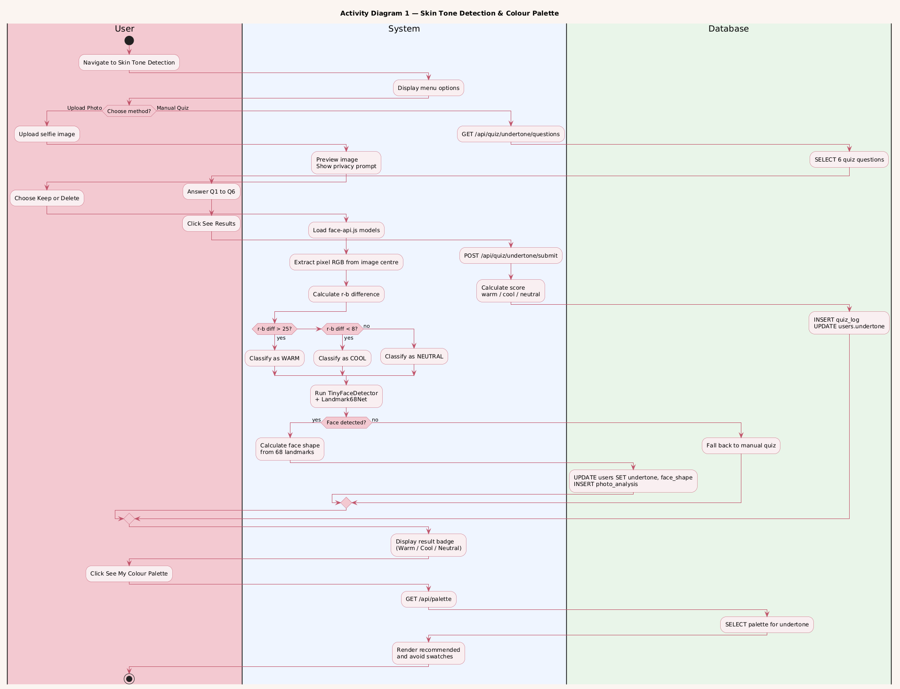

Wardrobe Upload & Outfit Suggestion (US-09)
Shows the flow from the user uploading a clothing item photo, system detecting its dominant color, user tagging the item, selecting an event type, the system generating outfit combinations, and the user bookmarking favourites.

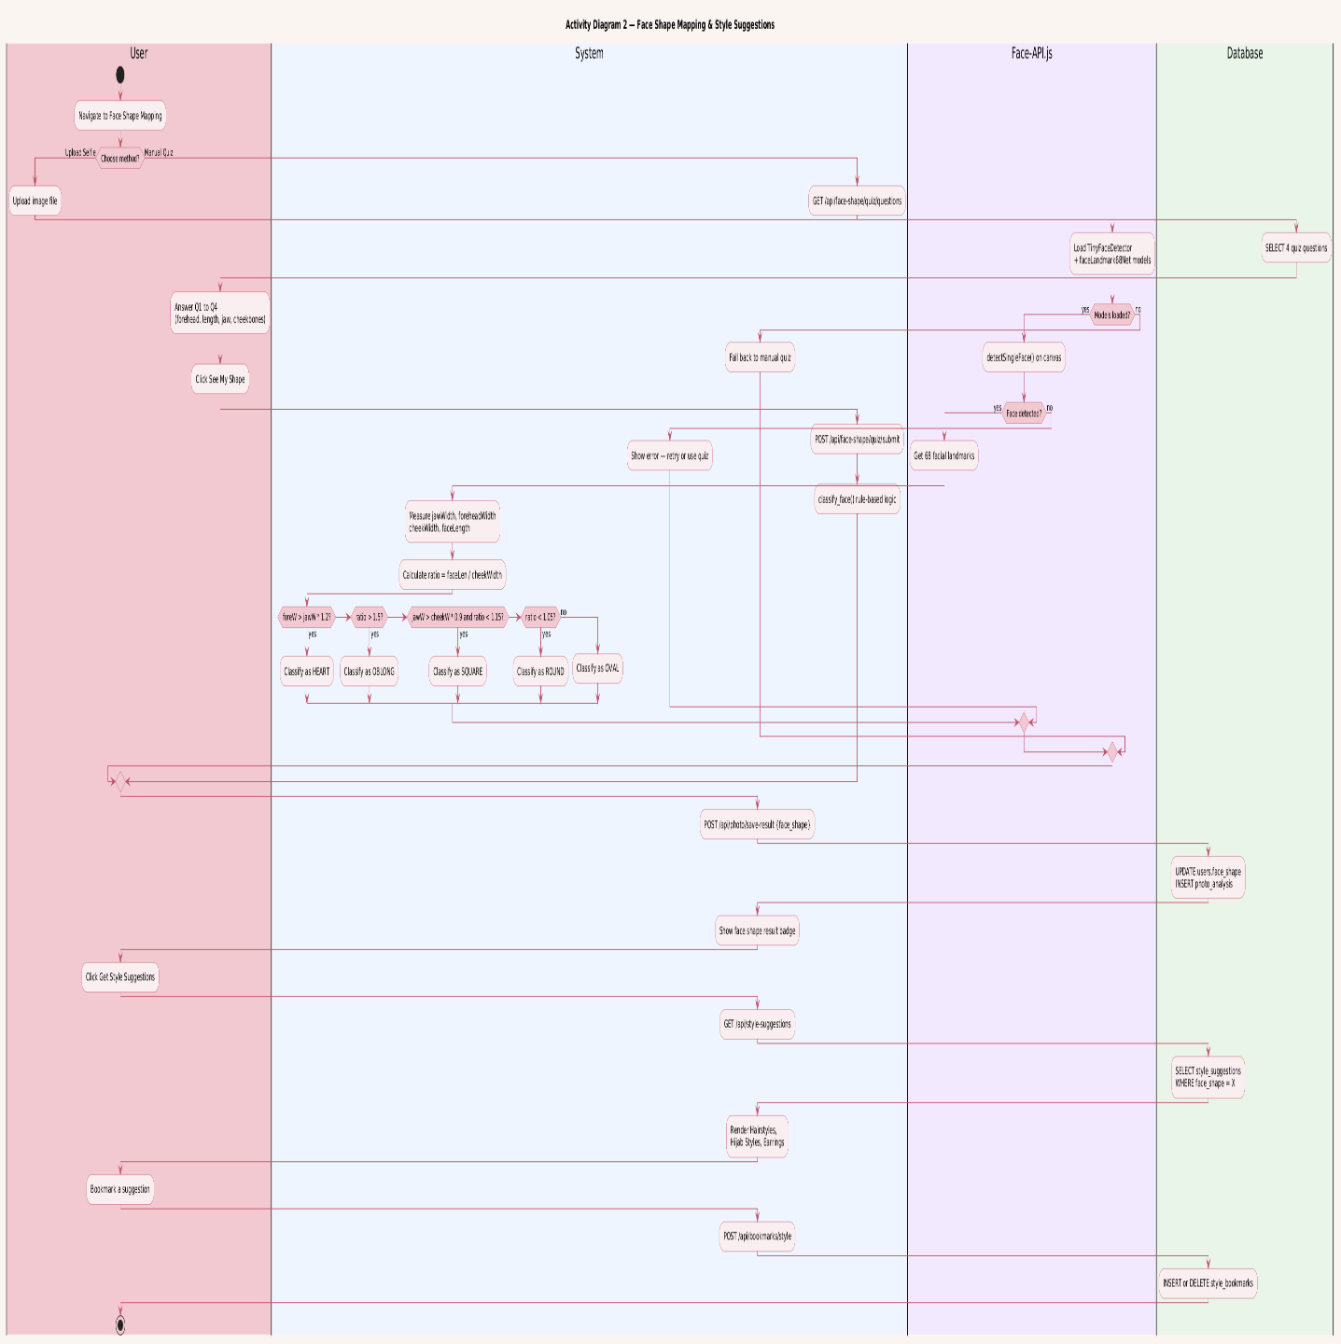

Face Shape Detection & Style Suggestions (US-07 & US-10)
Shows the flow from the system processing the selfie for face shape, classification or fallback quiz, displaying face shape result, and generating hairstyle, hijab, and earring suggestions linked to the detected shape.

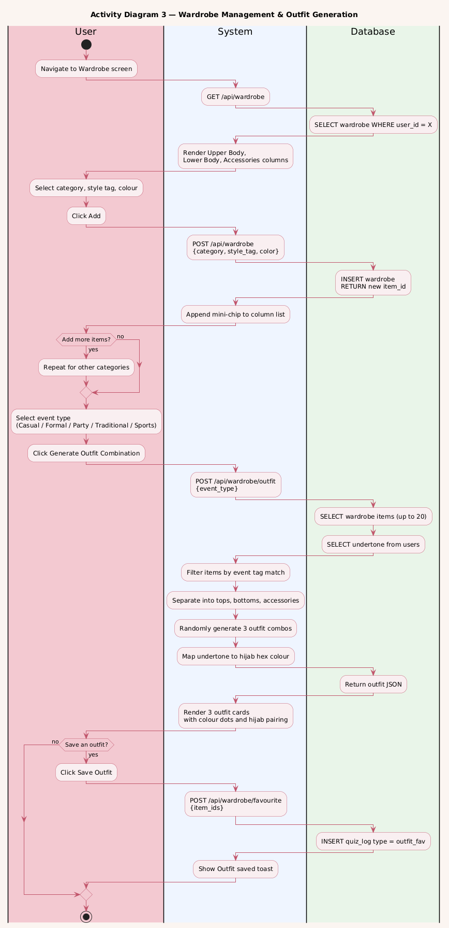

5.2.2 Use Case Diagram
The use case diagram below presents all actors and all use cases for the complete GlamMatch system as developed across Sprint 1 and Sprint 2.

Actors:
- User — primary actor; interacts with all styling, wardrobe, and salon features.
- Image Analysis Service — external/backend service that processes photos for skin tone and face shape.
- Admin — manages the product recommendation database and salon listings.

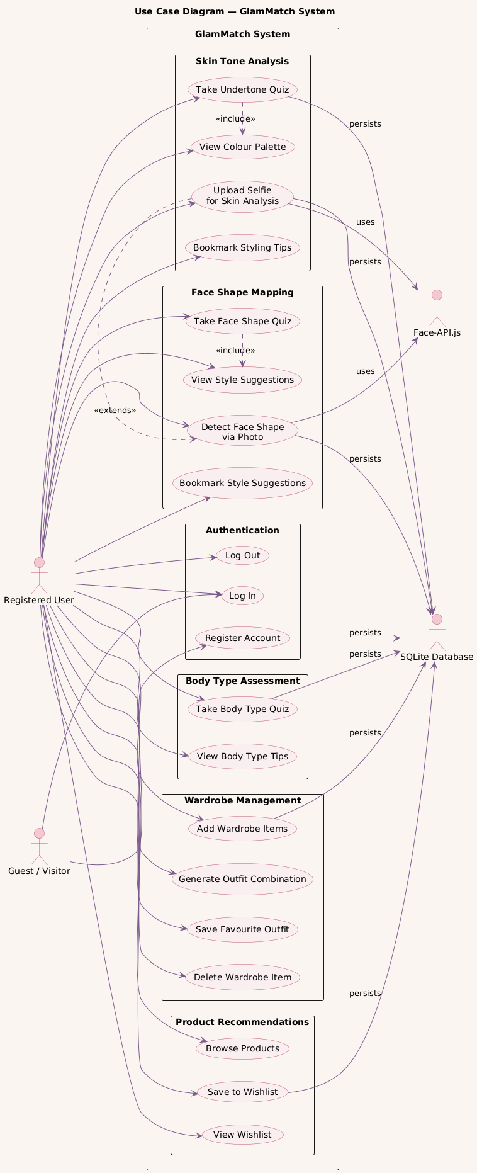

5.2.3 Sequence Diagrams
Sequence diagrams are provided for the three main activities of Sprint 2.

Sequence Diagram — Photo Upload & Skin Tone Analysis (US-06)
Participants: User → Frontend → Backend API → Image Analysis Service → Database. Shows the upload request, image forwarding, analysis response, profile update, and redirect to palette screen.

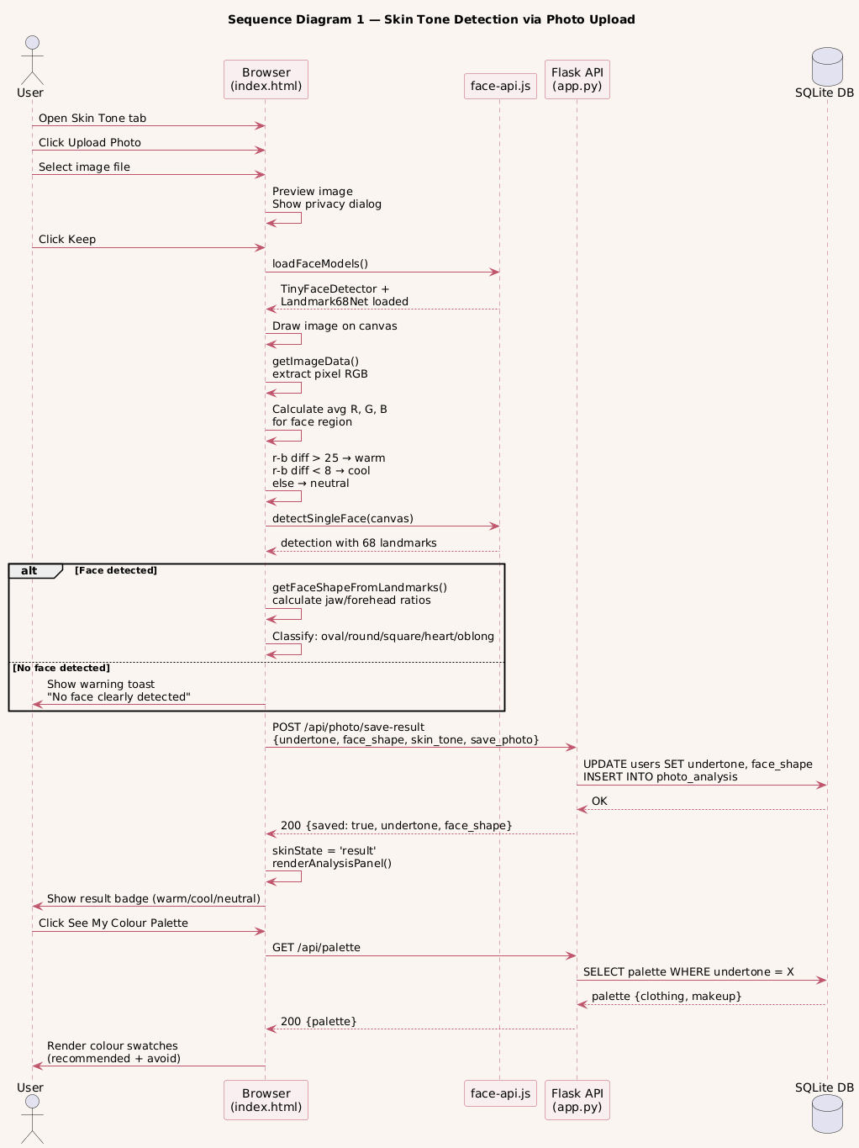

Sequence Diagram — Wardrobe Upload & Outfit Suggestion (US-09)
Participants: User → Frontend → Backend API → Color Detection Service → Database. Shows item upload, color detection call, tag submission, event selection, outfit generation, and wishlist save.

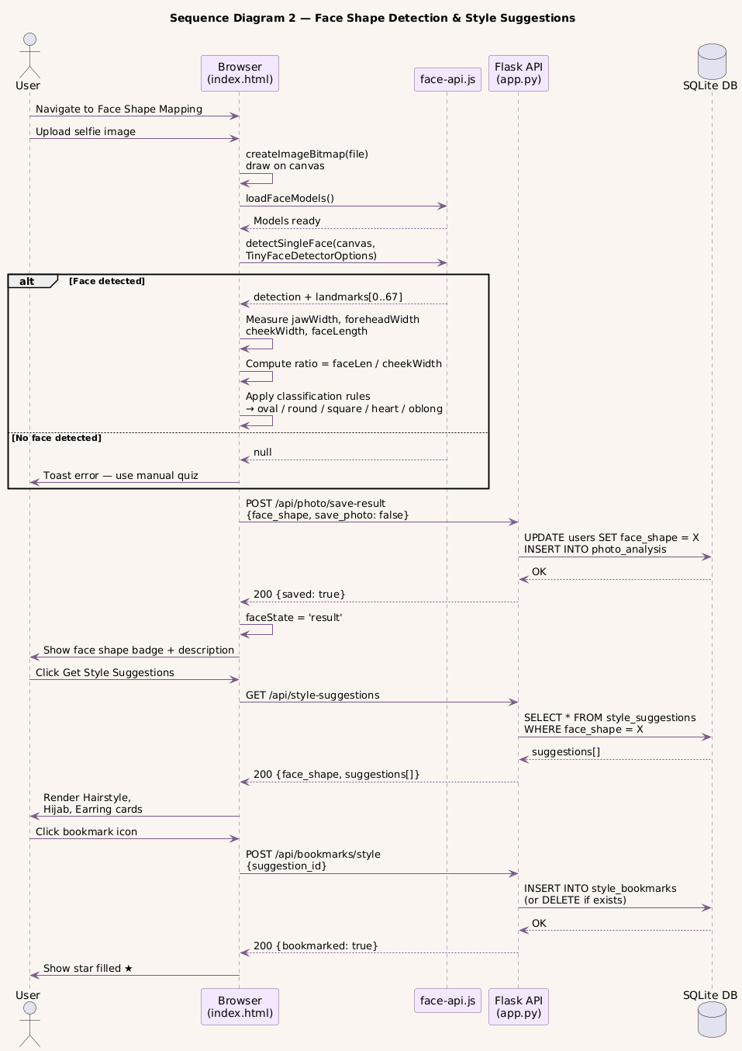

Sequence Diagram — Product Recommendations (US-08)
Participants: User → Frontend → Backend API → Recommendation Engine → Database. Shows profile data fetch, product lookup, tab rendering, and wishlist save interaction.
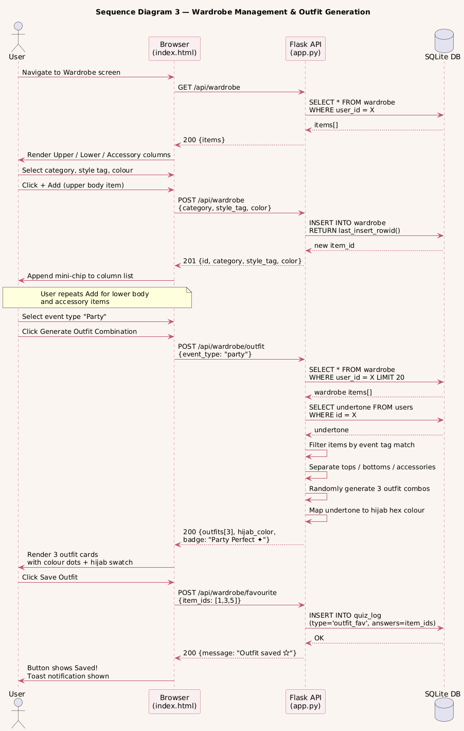

5.2.4 Class Diagram
The class diagram below shows all classes for Sprint 2 with their attributes, methods, and relationships.

Key classes and relationships:
- User — attributes: userId, name, email, passwordHash, undertone, skinTone, faceShape, bodyType
- Photo — attributes: photoId, userId, filePath, uploadDate, isDeleted | User 1—* Photo
- SkinToneResult — attributes: resultId, userId, skinTone, undertone, method (photo/quiz) | User 1—1 SkinToneResult
- FaceShapeResult — attributes: resultId, userId, faceShape, confidence | User 1—1 FaceShapeResult
- WardrobeItem — attributes: itemId, userId, photoPath, dominantColor, clothingType, style | User 1—* WardrobeItem
- OutfitSuggestion — attributes: suggestionId, userId, itemIds[], eventType, hijabColor, isFavourite | OutfitSuggestion aggregates WardrobeItem
- ProductRecommendation — attributes: productId, category, undertone, bodyType, brand, shadeName, swatchColor, productLink
Wishlist — attributes: wishlistId, userId, productId, savedAt | resolves User M—N ProductRecommendation

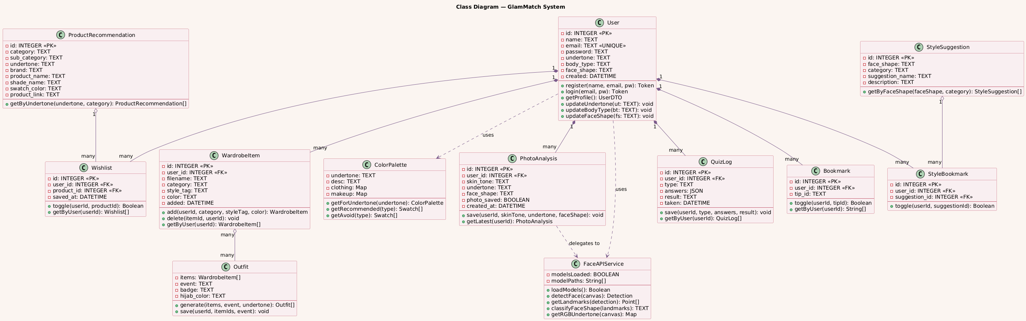

5.3 Sprint 3 UI Design Summary
Screen | Main UI Elements | Related User Story
Salon Finder | Search bar, service filter, price filter, category filter, salon cards with rating and address | US-11
Salon Profile | Salon details, working hours, phone, service catalog, reviews, Book Appointment button | US-12
Booking Screen | Service dropdown, date/time input, optional note, submit booking button | US-13
My Bookings | Booking cards, status badges, action buttons for cancel/complete/accept alternate | US-13
Chat Screen | Message bubbles, timestamps, input field, send button | US-14
Review Screen | 5-star rating selector, review textarea, submit button | US-15

6. Architecture

6.1 Selected Architecture Pattern
The selected architecture pattern for GlamMatch is Layered (N-Tier) Architecture. This pattern is appropriate because the project has a clear separation between the user interface, business rules, and database. The frontend remains responsible for screens and user interaction; the backend contains application logic and validation; and SQLite stores persistent records.

6.2 Project-Specific Architecture Diagram
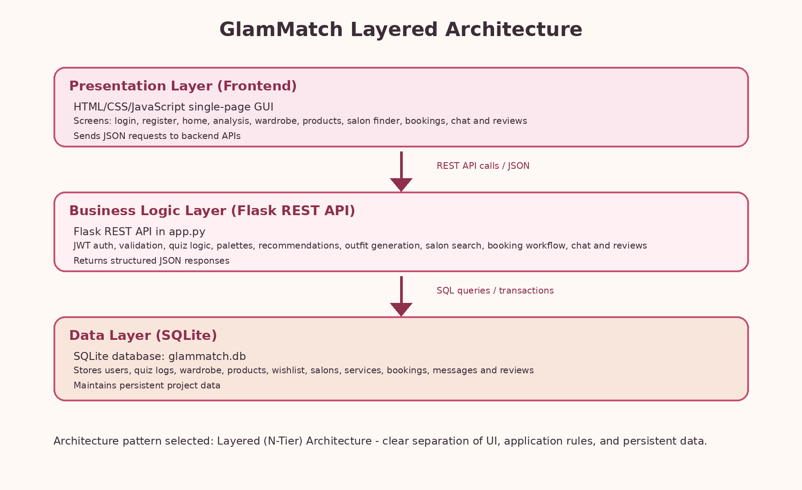
Figure 5: Layered Architecture Diagram for GlamMatch

7. Actual Implementation Screenshots
This section is arranged so screenshots can be pasted directly from the running application. Sprint 2 reference screenshots are inserted where available. For Sprint 3 screens, screenshot placeholder boxes are included and should be replaced with actual screenshots captured from localhost:5000 before final submission.

7.1 Existing Implementation Screenshots from Styling Module
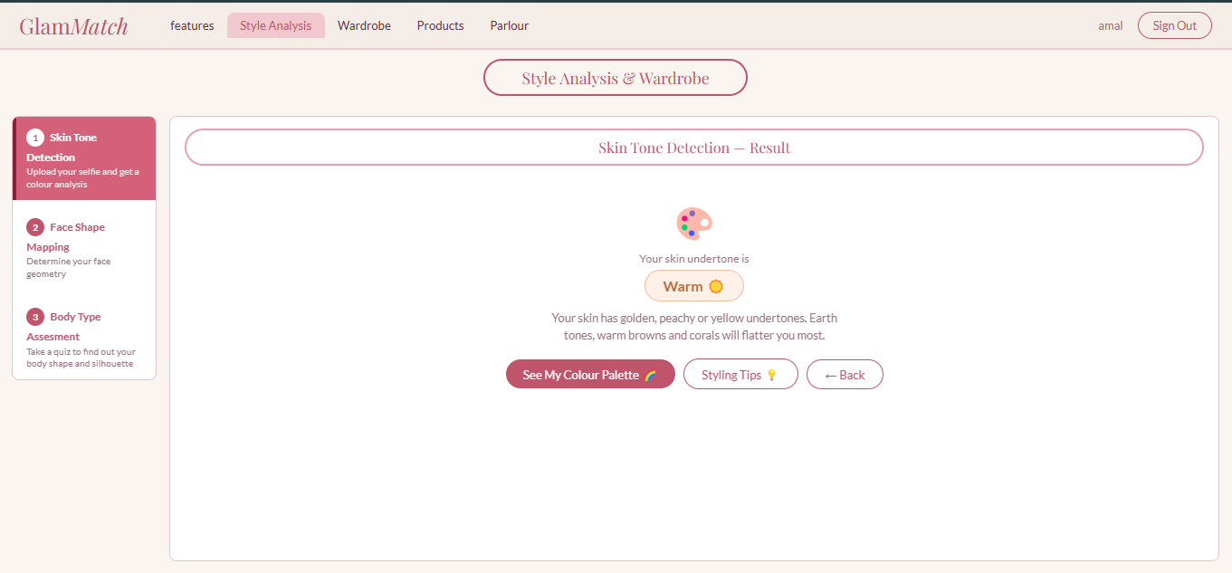
Skin Tone Detection Result Screen

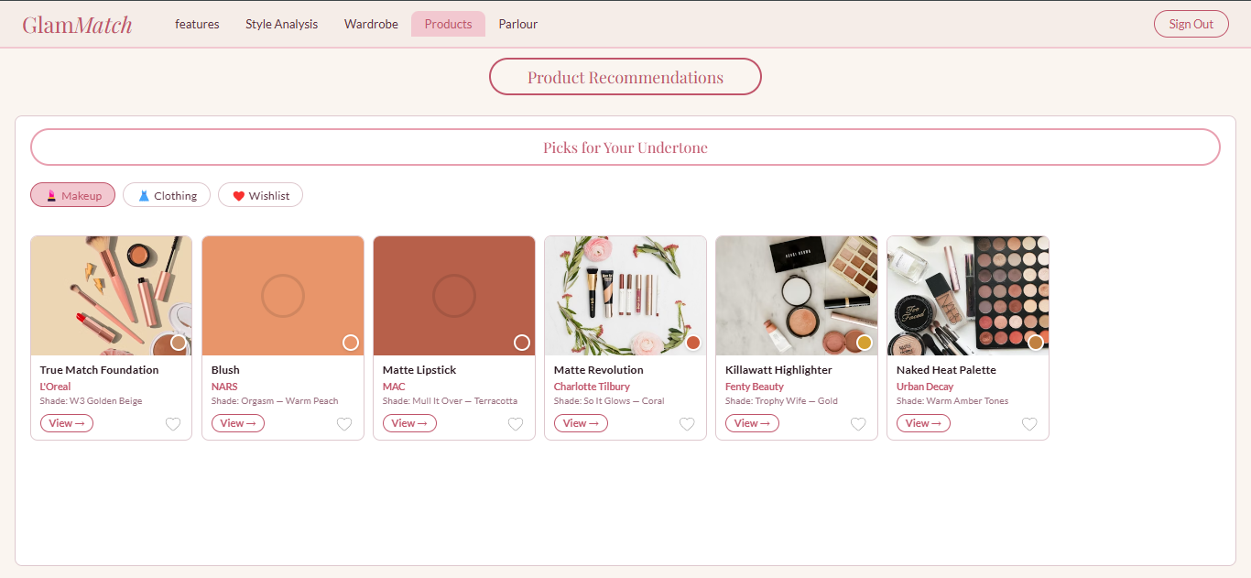
Product Recommendations - Makeup Tab

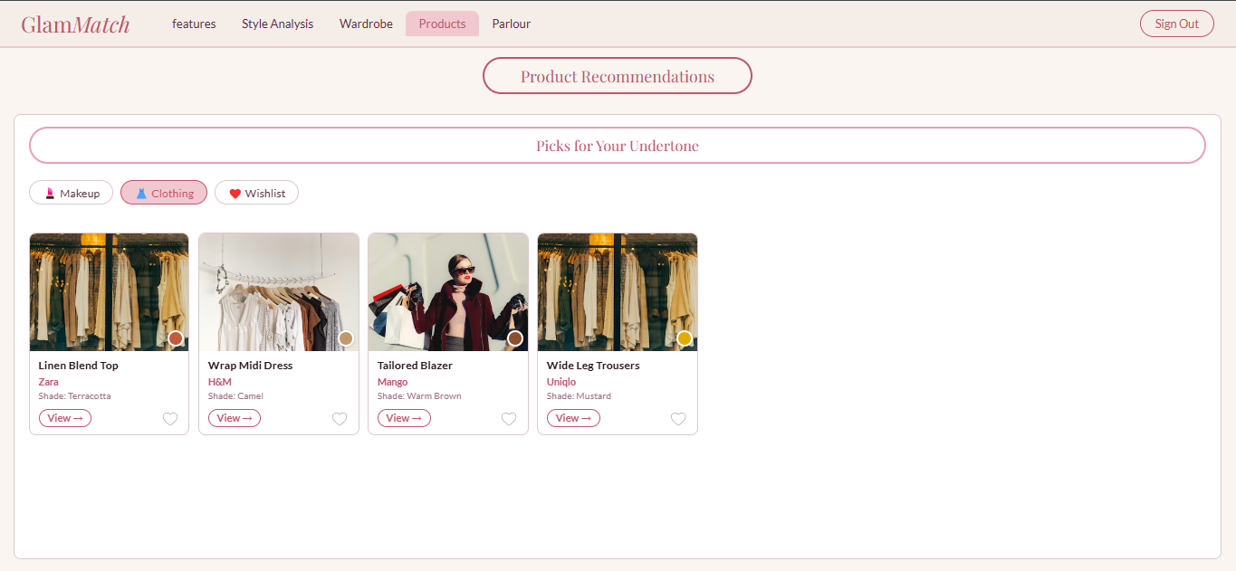
Product Recommendations - Clothing Tab

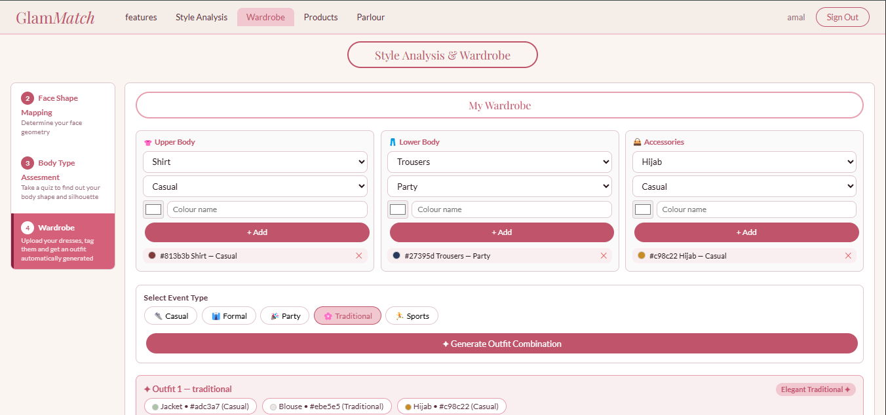
Wardrobe and Outfit Combination Screen

7.2 Sprint 3 Screenshots to Replace with Actual Running GUI Captures
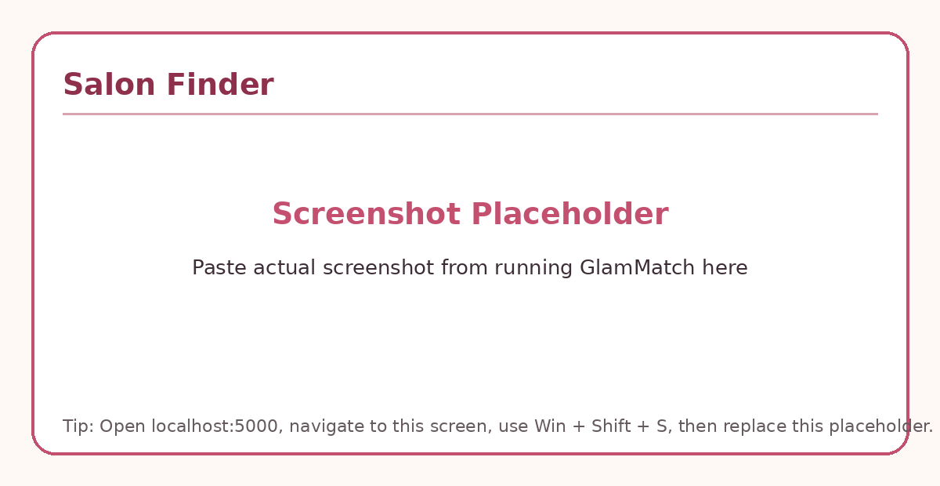
Salon Finder - replace placeholder with actual screenshot

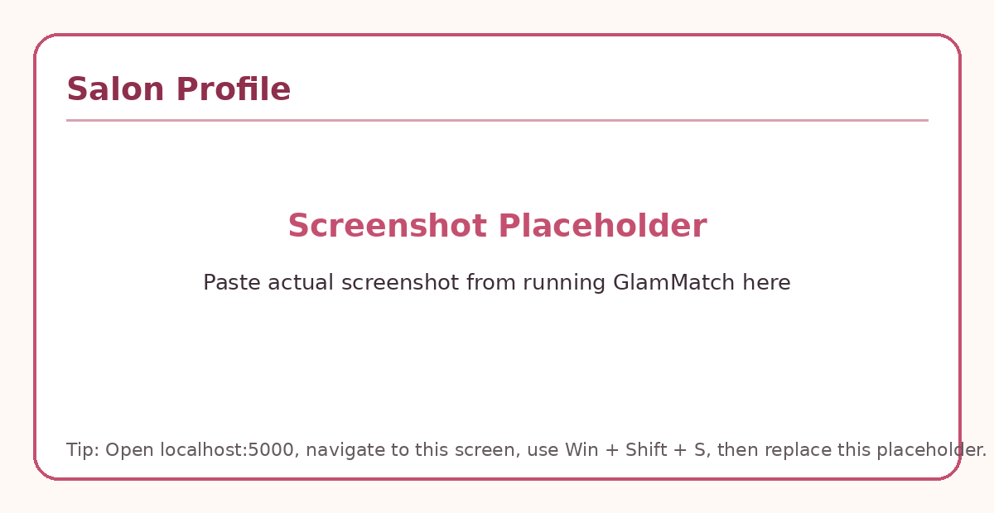
Salon Profile - replace placeholder with actual screenshot

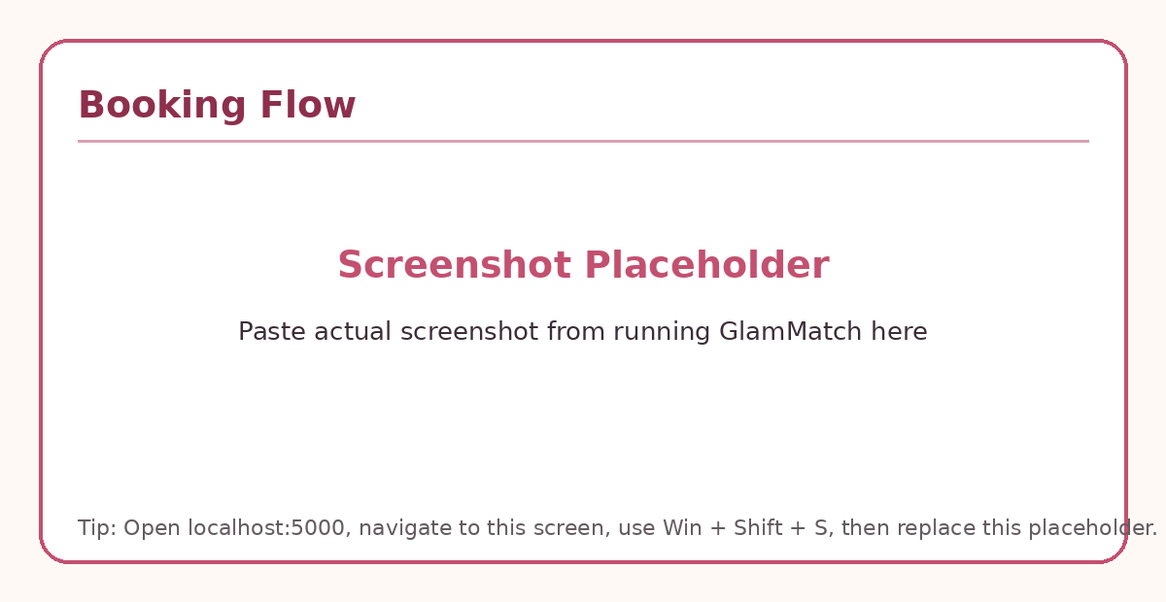
Booking Flow - replace placeholder with actual screenshot

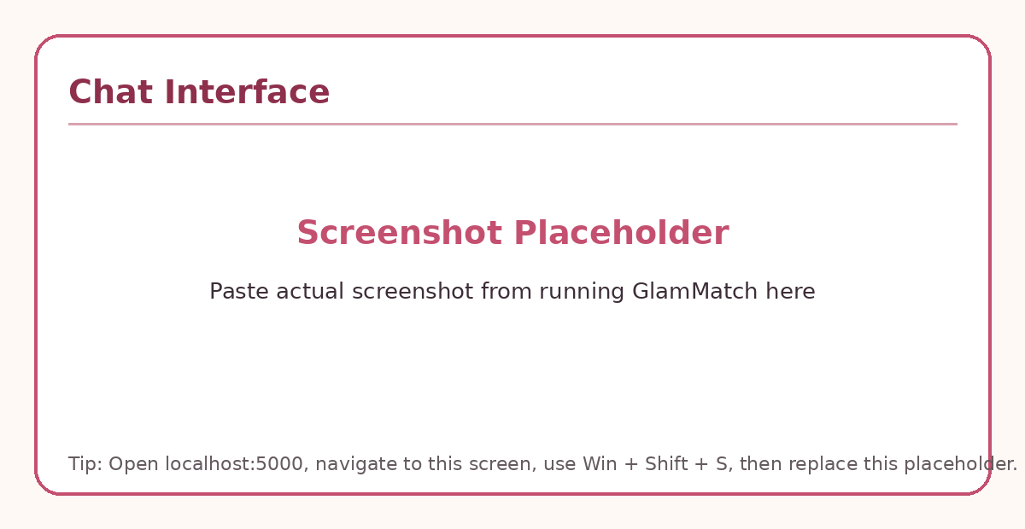
Chat Interface - replace placeholder with actual screenshot

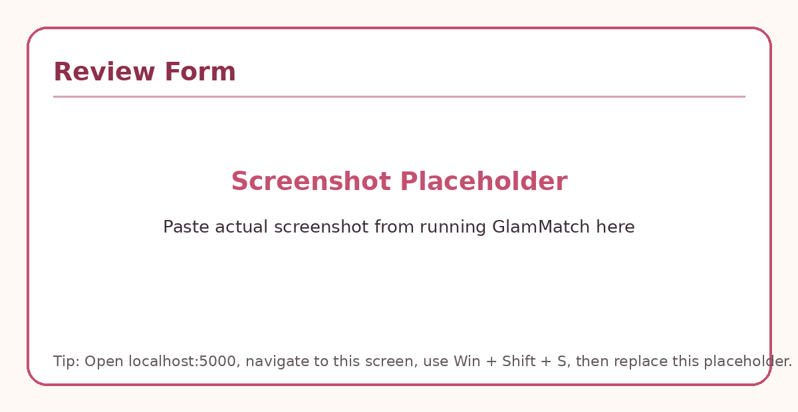
Review Form - replace placeholder with actual screenshot

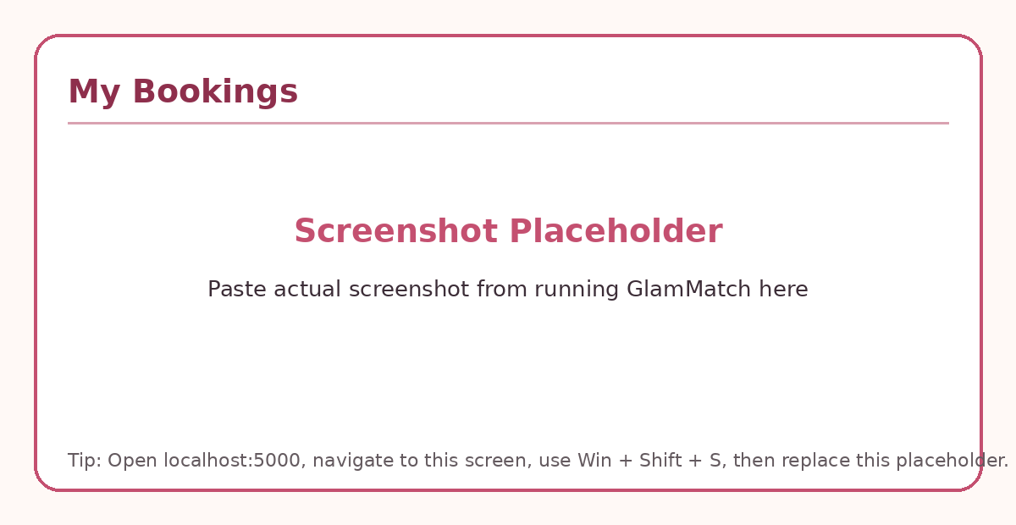
My Bookings - replace placeholder with actual screenshot

8. Product Burndown Chart and Trello Board

8.1 Product Burndown Chart
The product burn-down chart below tracks planned story points remaining versus actual story points remaining for the complete GlamMatch project. Story points were finalized from the earlier iteration documents: Sprint 1 = 28 points (US-01: 5, US-02: 5, US-03: 8, US-04: 5, US-05: 5), Sprint 2 = 39 points (US-06: 8, US-07: 8, US-08: 8, US-09: 10, US-10: 5), and Sprint 3 = 28 points (US-11: 5, US-12: 5, US-13: 8, US-14: 5, US-15: 5). Total product story points: 95.
Sprint Stage | Planned Points  Remaining | Actual Points  Remaining | User Stories Completed | Notes
Project Start | 95 | 95 | US-01 to US-15 planned | Product backlog finalized
After Sprint 1 | 67 | 67 | US-01 to US-05 completed | Core styling system completed
After Sprint 2 | 28 | 30 | US-06 to US-09 completed; US-10 mostly completed | Minor US-10 rework carried to Sprint 3
Mid Sprint 3 | 14 | 12 | US-11, US-12 and booking flow completed; rework closed | Sprint 3 slightly ahead of ideal line
After Sprint 3 | 0 | 0 | US-11 to US-15 completed | No story points left
Table 7: Product Burndown Summary - Planned vs Actual Remaining Points

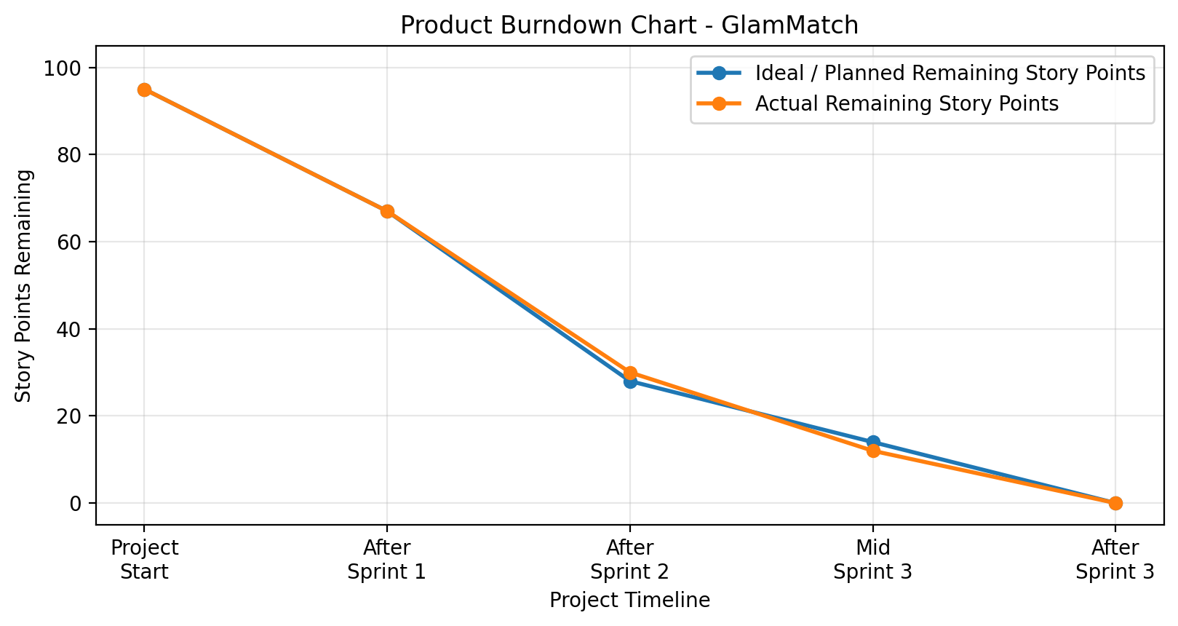
Figure 7: Product Burndown Chart - Ideal and Actual Remaining Story Points

8.2 Scrum Board — Trello Board Screenshots
Actual Trello board screenshots should be pasted here for Sprint 3 start, mid-sprint progress, and sprint completion. A clean Sprint 3 board mock-up is included below only as a layout guide.

Screenshot 1 — Sprint Start: All US-11 to US-15 in ‘To Do’

Screenshot 2 — Mid Sprint: US-11 & US-12 Done, US-13 In Progress

Screenshot 3 — Sprint End: All Stories Completed

9. Boundary Value Analysis Testing - Signup and Login
Boundary Value Analysis was performed on the implemented Signup and Login interfaces. The signup route validates name, email and password; the login route validates the provided email/password combination against stored hashed credentials.

9.1 Signup - Password Boundary Tests
TC ID | Input Password | Boundary Condition | Expected Result | Actual Result | Status
SU-PW-01 | abc123 | 6 characters, has digit | Reject - below 8 characters | Password must be 8+ characters with at least one number | Pass
SU-PW-02 | abcdefg | 7 characters, no digit | Reject - below 8 and no digit | Password must be 8+ characters with at least one number | Pass
SU-PW-03 | abcdefg1 | 8 characters, has digit | Accept - valid lower boundary | Account created if email is new | Pass
SU-PW-04 | abcdefgh | 8 characters, no digit | Reject - missing number | Password must be 8+ characters with at least one number | Pass
SU-PW-05 | abcdefghi1 | 10 characters, has digit | Accept - valid above boundary | Account created if email is new | Pass

9.2 Signup - Email and Required Field Tests
TC ID | Input | Boundary / Error Condition | Expected Result | Actual Result | Status
SU-EM-01 | Empty name/email/password | Required fields missing | Reject | All fields are required | Pass
SU-EM-02 | userexample.com | Missing @ symbol | Reject | Enter a valid email address | Pass
SU-EM-03 | user@domain.com | Valid email format | Accept if password/name valid and email new | Account created | Pass
SU-EM-04 | Existing email | Duplicate unique email | Reject duplicate account | Email already registered - please sign in | Pass

9.3 Login - Credential Boundary Tests
TC ID | Email | Password | Expected Result | Actual Result | Status
LG-01 | registered email | correct password | Accept login | JWT token returned and user redirected to Home | Pass
LG-02 | registered email | wrong password | Reject login | Incorrect email or password | Pass
LG-03 | unregistered email | any password | Reject login | Incorrect email or password | Pass
LG-04 | empty email | empty password | Reject login | Incorrect email or password | Pass
LG-05 | email with uppercase letters | correct password | Accept after lowercase normalization | JWT token returned | Pass

10. Work Division Between Group Members
Member | Sprint 3 Responsibilities | Overall Contribution
Ayza Ahmed (24L-2577) | Sprint 3 backlog, user stories US-11 to US-15, acceptance criteria, rework table, BVA documentation, final report compilation. | Project planning, requirement engineering, iteration tracking, report/presentation structure.
Eman Adil (24L-2589) | Backend routes for salons, bookings, chat and reviews; database tables and seed data; validation and API testing. | Backend APIs, SQLite schema design, authentication, quiz logic, photo result saving, products, wardrobe, salon connector.
Anoushay Fatima (24L-2585) | Frontend GUI screens for Salon Finder, Salon Profile, Booking, My Bookings, Chat and Review; UI testing and screenshot preparation. | Frontend UI/UX implementation, prototype screens, styling consistency, QA and Trello snapshots.

11. Lessons Learned by the Group
- Iterative development made the project easier to control because each sprint delivered a working part of the system before moving to the next module.
- Clear user stories and acceptance criteria helped the team know when a feature was complete and prevented scope creep.
- Layered architecture improved debugging because frontend UI issues, backend logic issues, and database issues could be checked separately.
- Database planning is important because Sprint 3 needed several related tables: salons, salon_services, bookings, chat_messages and reviews.
- Boundary testing is necessary even when the form works normally because edge cases such as 7-character passwords, duplicate emails, and empty login fields reveal validation weaknesses.
- Team coordination through Trello helped track To Do, In Progress, Review, and Done tasks across all sprint features.

